SOHANUR RAHMAN SUMON
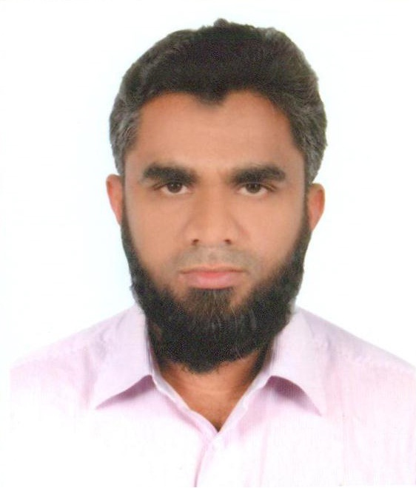

Mail: srahman.sumon@gmail.com | Call: +880 1962 400930 & +880 1716 637689 | Skype: sohanursumon
Post: 238/1 -E, Str. Ahammad Nagar, Paik Para, Mirpur - 1, Dhaka - 1216.

Career Objective:

Utilize creative & strategic competencies and leadership capabilities to add values in achieving the organizational goals.

Career Summary:

9+ years’ experience in sales channel operations simplification & automation, sales channel development, business development and regional sales with Banglalink Digital Communications Limited and Berger Paints Bangladesh Ltd.

Employment History:

Digital Distribution Senior Manager, Digital
Banglalink Digital Communications Limited, April 01, 2018 – Continuing.

- Drive digital distribution initiatives that span across operating costs optimization, third party integration, process simplification & automation, and data-driven decision making.

Digital Channel Manager, Marketing
Banglalink Digital Communications Limited, October 01, 2015 – March 31, 2018.

- Launched eShop for Banglalink products & services.

- Introduced top-up service into ATM booth & internet banking of major commercial banks.

- Launched ‘International Top – up.' This alternate sales channel enables Non-Resident Bangladeshi (NRB) to top –up any Banglalink number (both prepaid & postpaid) of their loved ones in Bangladesh from abroad.

- Introduced top-up service into employees' pool phone through SMS or USSD.

Channel Strategy Assistant Manager, Marketing
Banglalink Digital Communications Limited, January 07, 2013 – September 30, 2015.

- Designed and monitored channel campaigns to drive subscriber acquisition in the form of gross-add, net-add and win-back and also the volume of secondary and tertiary recharges in trade.

- Introduced 'Distribution Operation & Performance Audit’, a check – and – balance tool for Banglalink and its distributors to measures effectiveness & efficiency distribution systems.

- Contributed to roll out training programs at the regional level to develop sales forces to bring alignment with distribution development strategy.

- Led the trade commission team and redesigned the commission disbursement modality through introducing;

- On-The-Fly (OTF): Retailers get their commission instantly just after recharging an offer to a customer.

- Direct to Retailer (DTR): Retailers receive all performance-based incentives directly to their wallet within the shortest possible time. First of its kind in Telecom Industry in Bangladesh.

Territory Officer, Sales & Marketing
Berger Paints Bangladesh Ltd, January 04, 2011 – December 31, 2012.

Looked after the entire portfolio of the wood coatings business that covered both trade sales & business development.

Educations:

- Master of Business Administration (MBA) in Strategic and International Management from University of Dhaka. CGPA obtained – 3.63 out of 4.00 scale. Passing Year – 2010.

- Bachelor of Business Administration (BBA) in Management Studies from University of Dhaka. CGPA obtained – 3.36 out of 4.00 scale. Passing Year – 2009.

